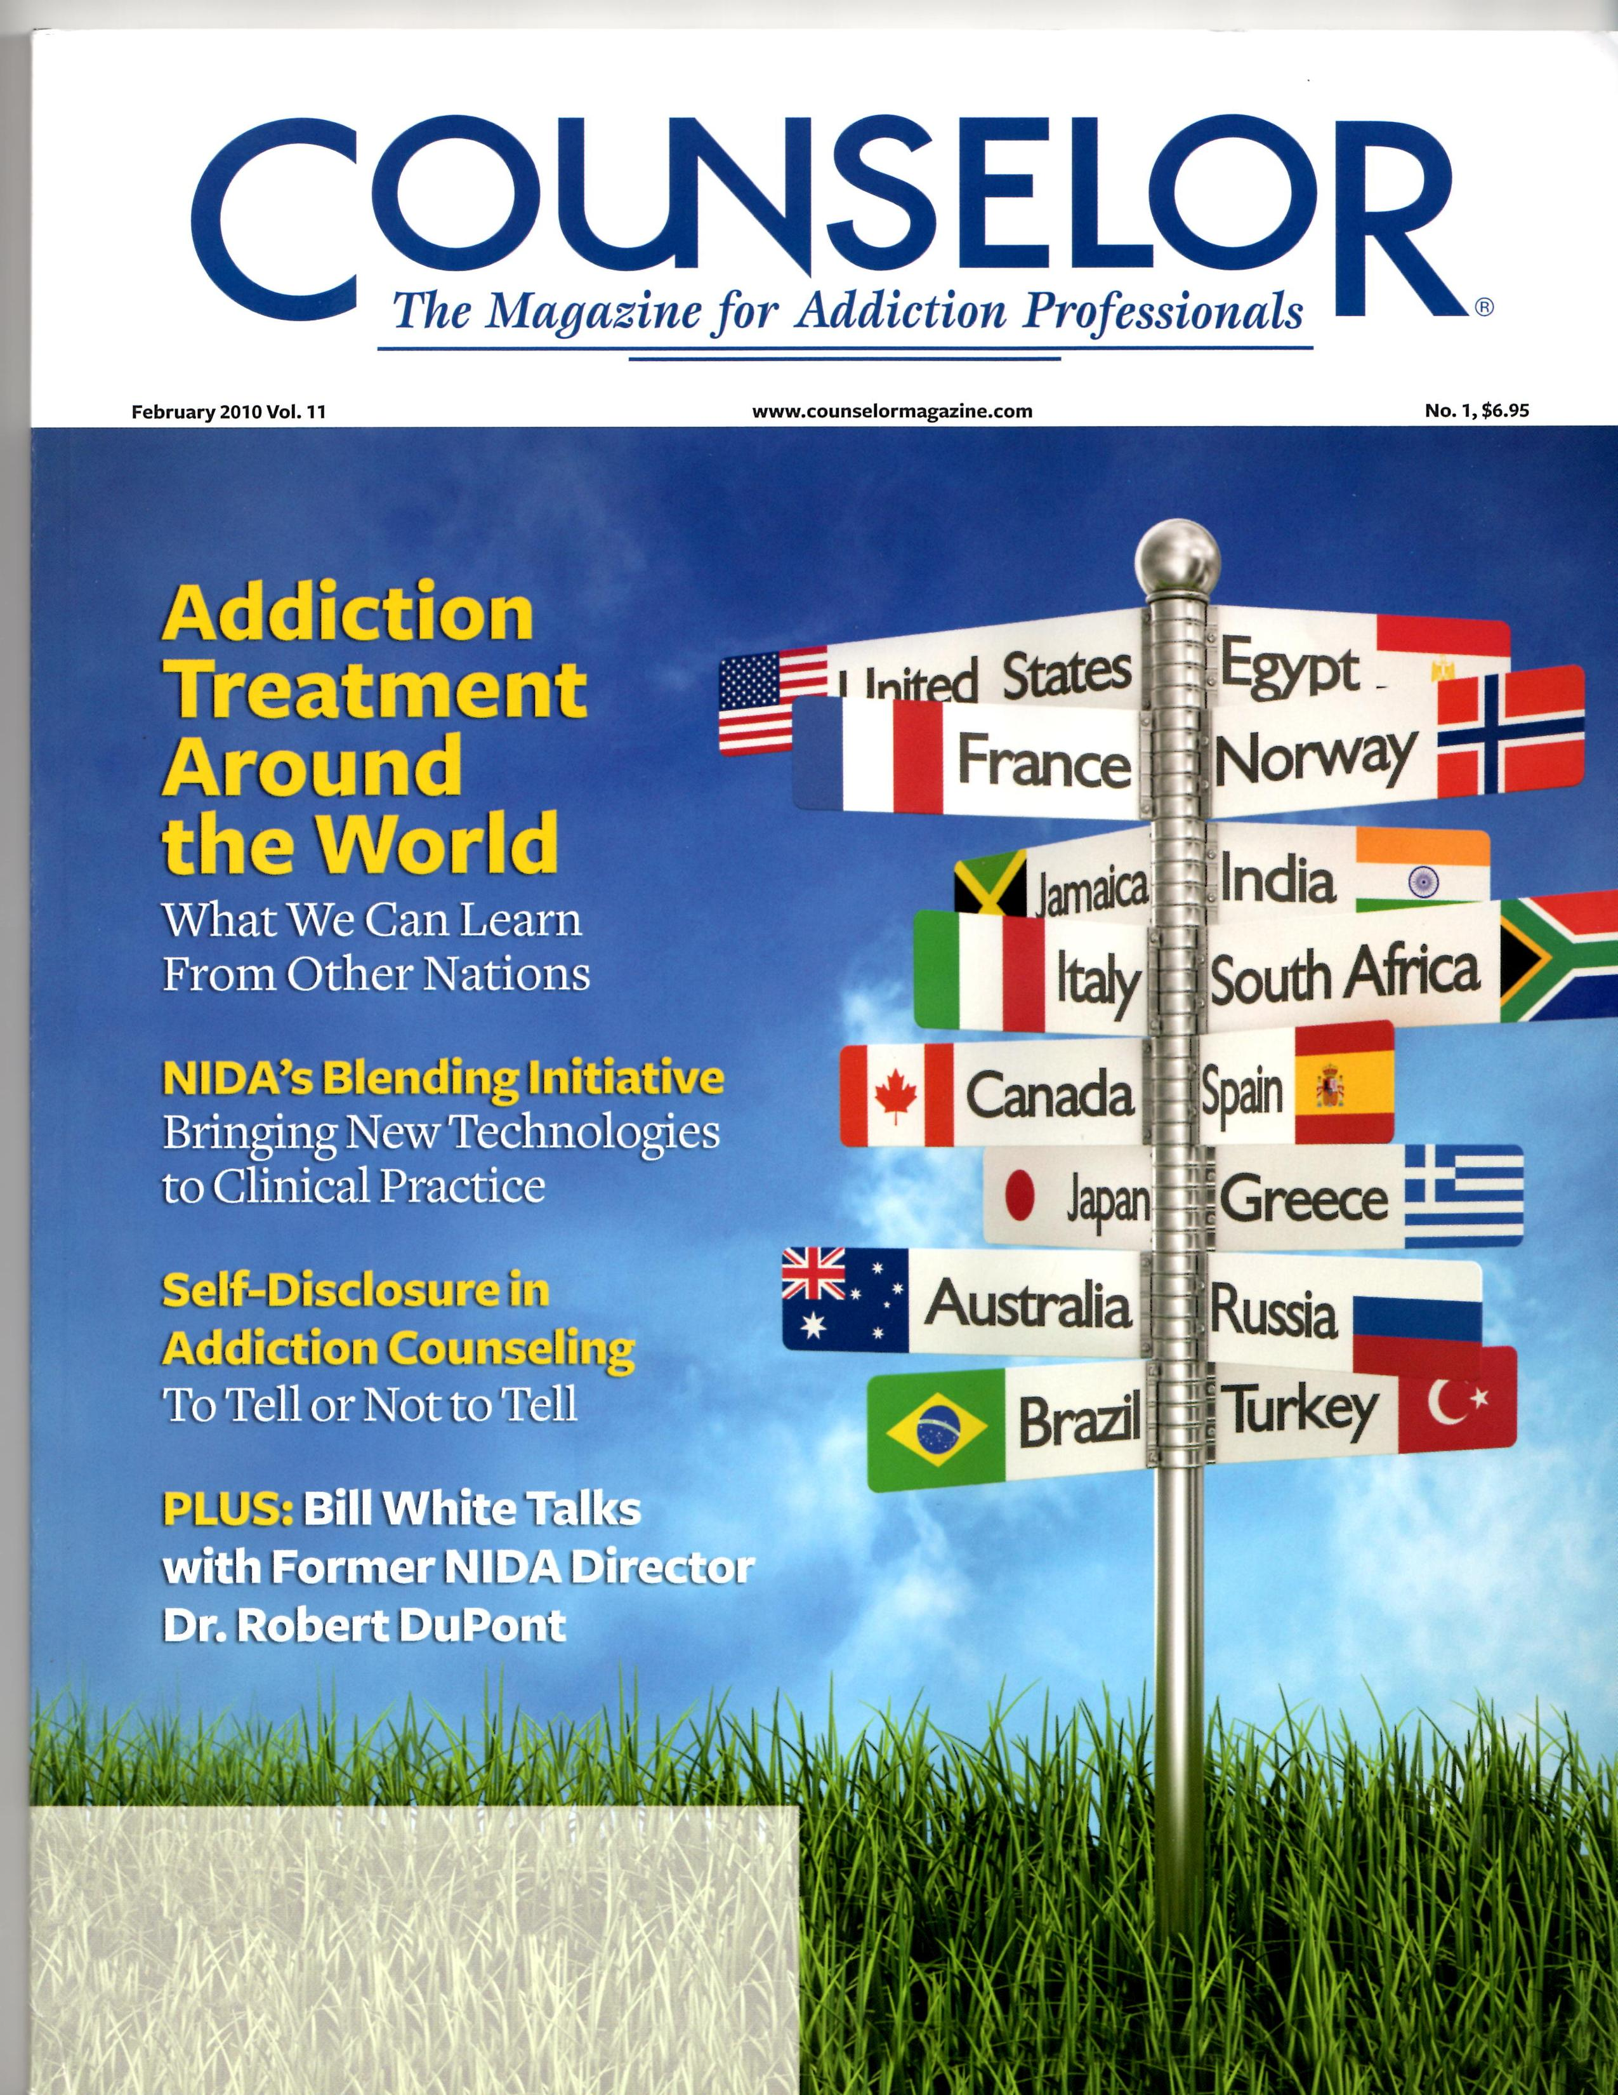

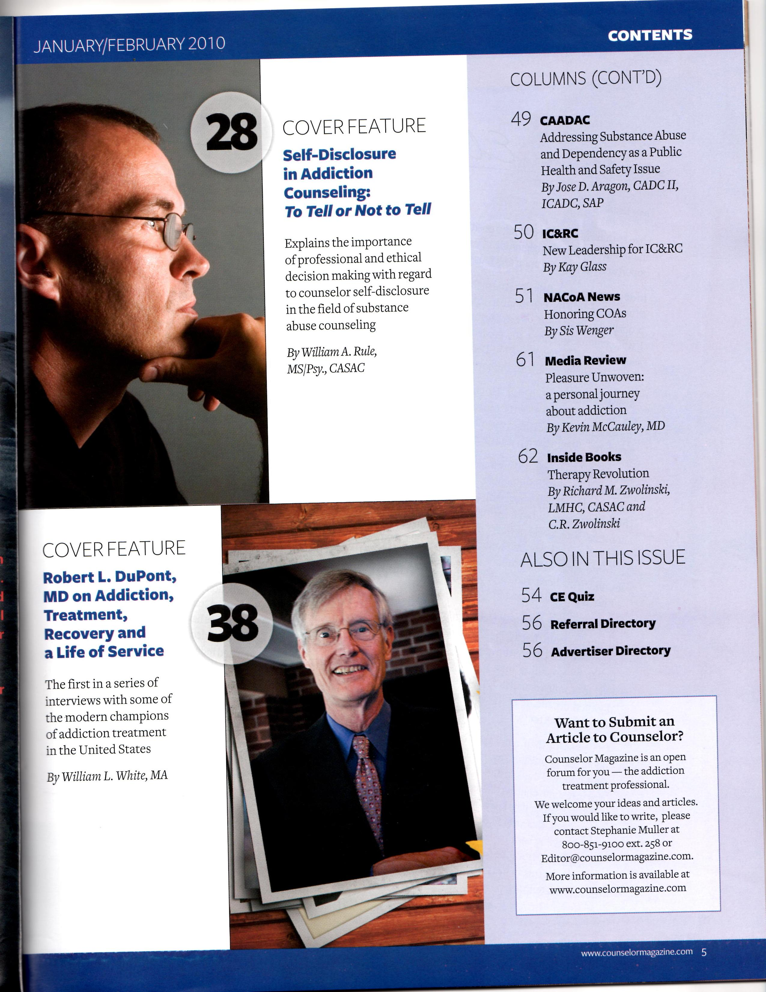

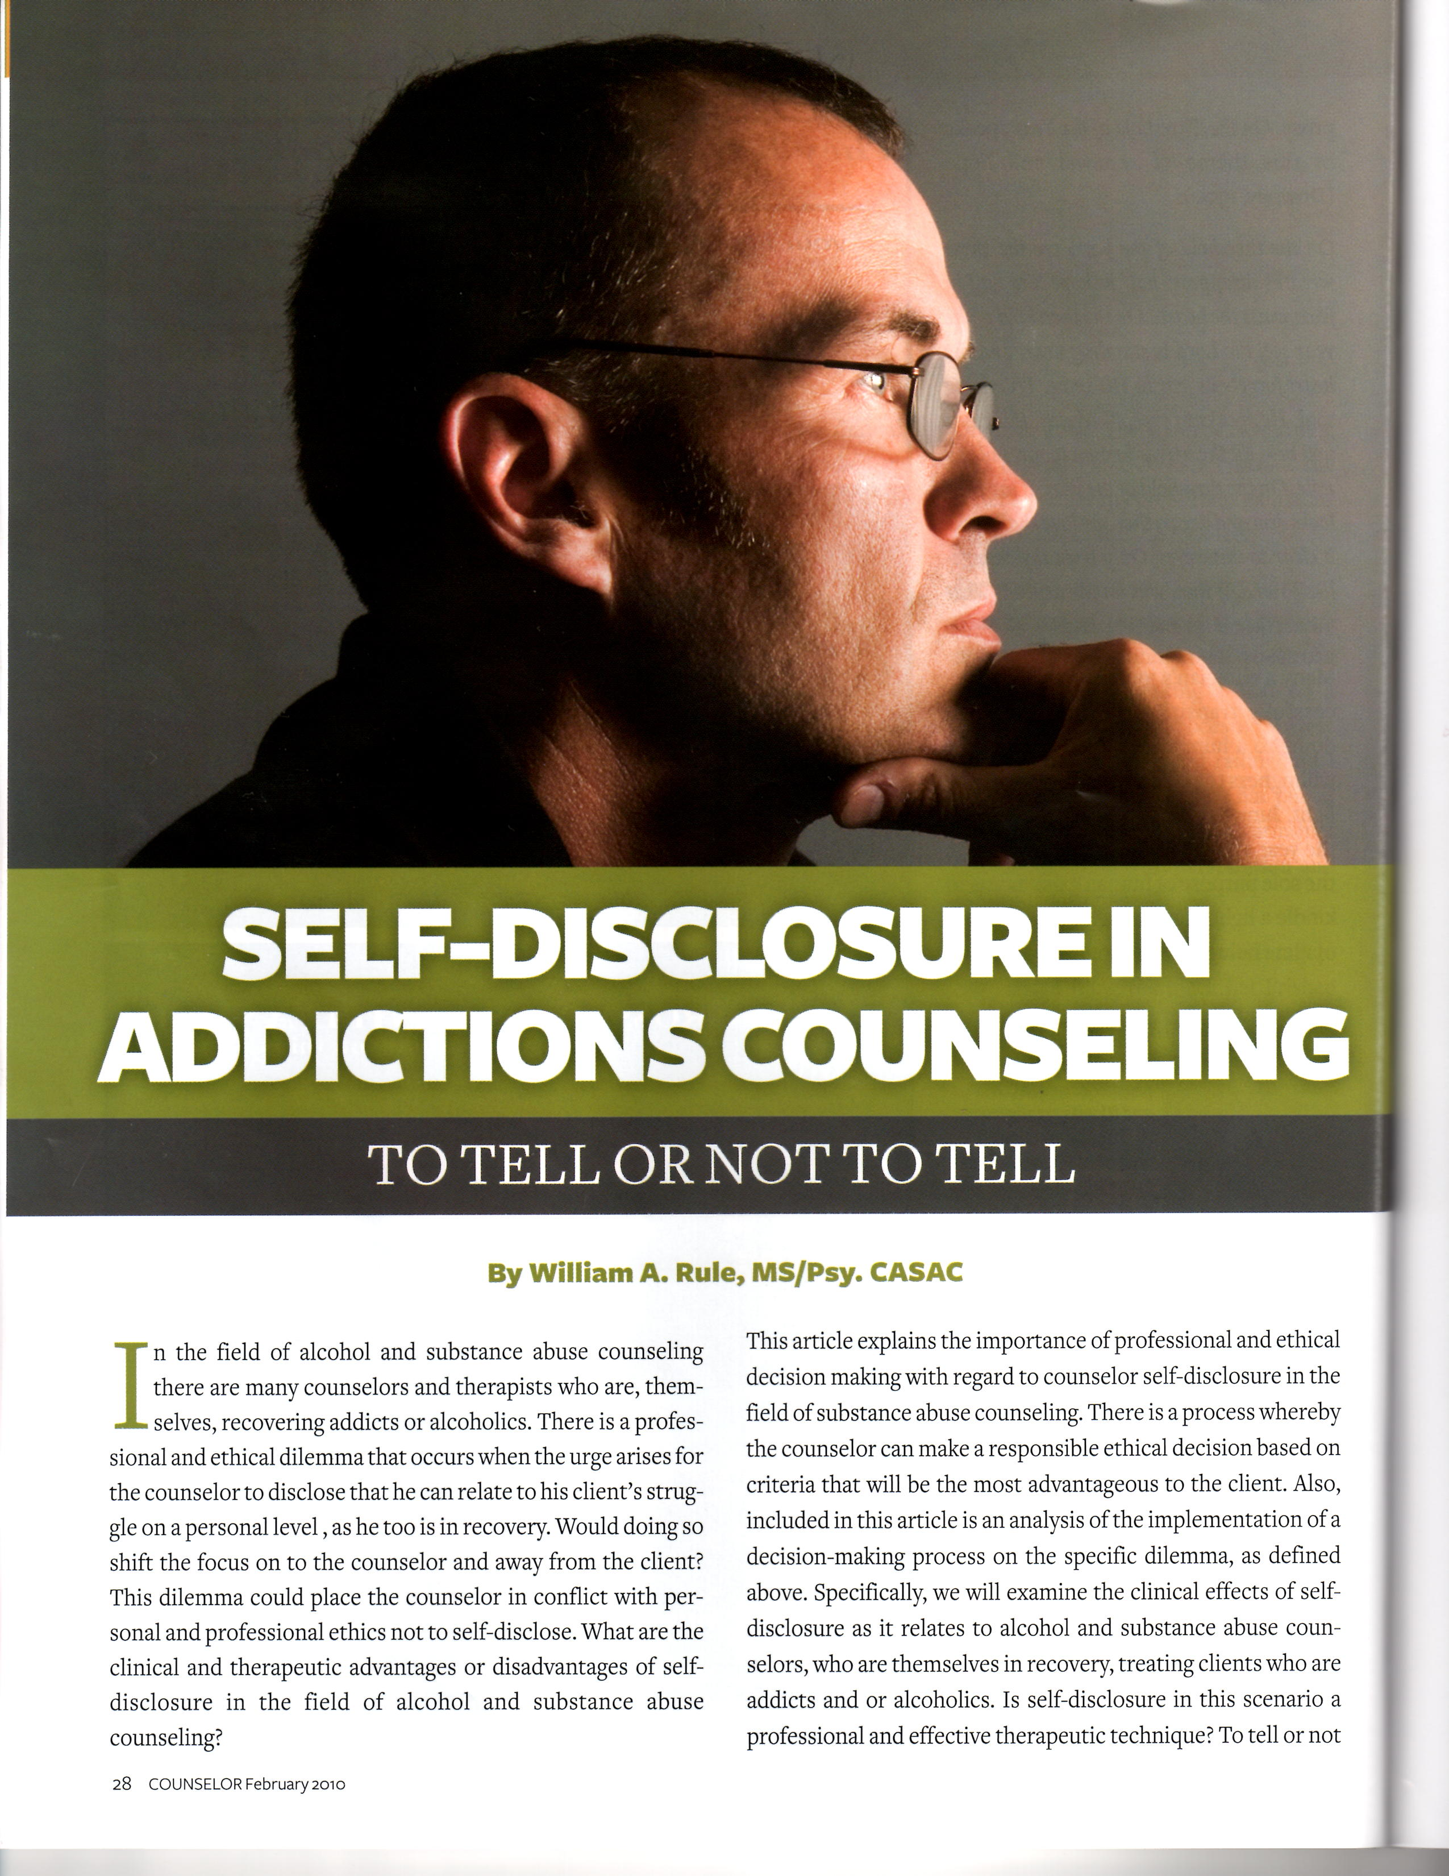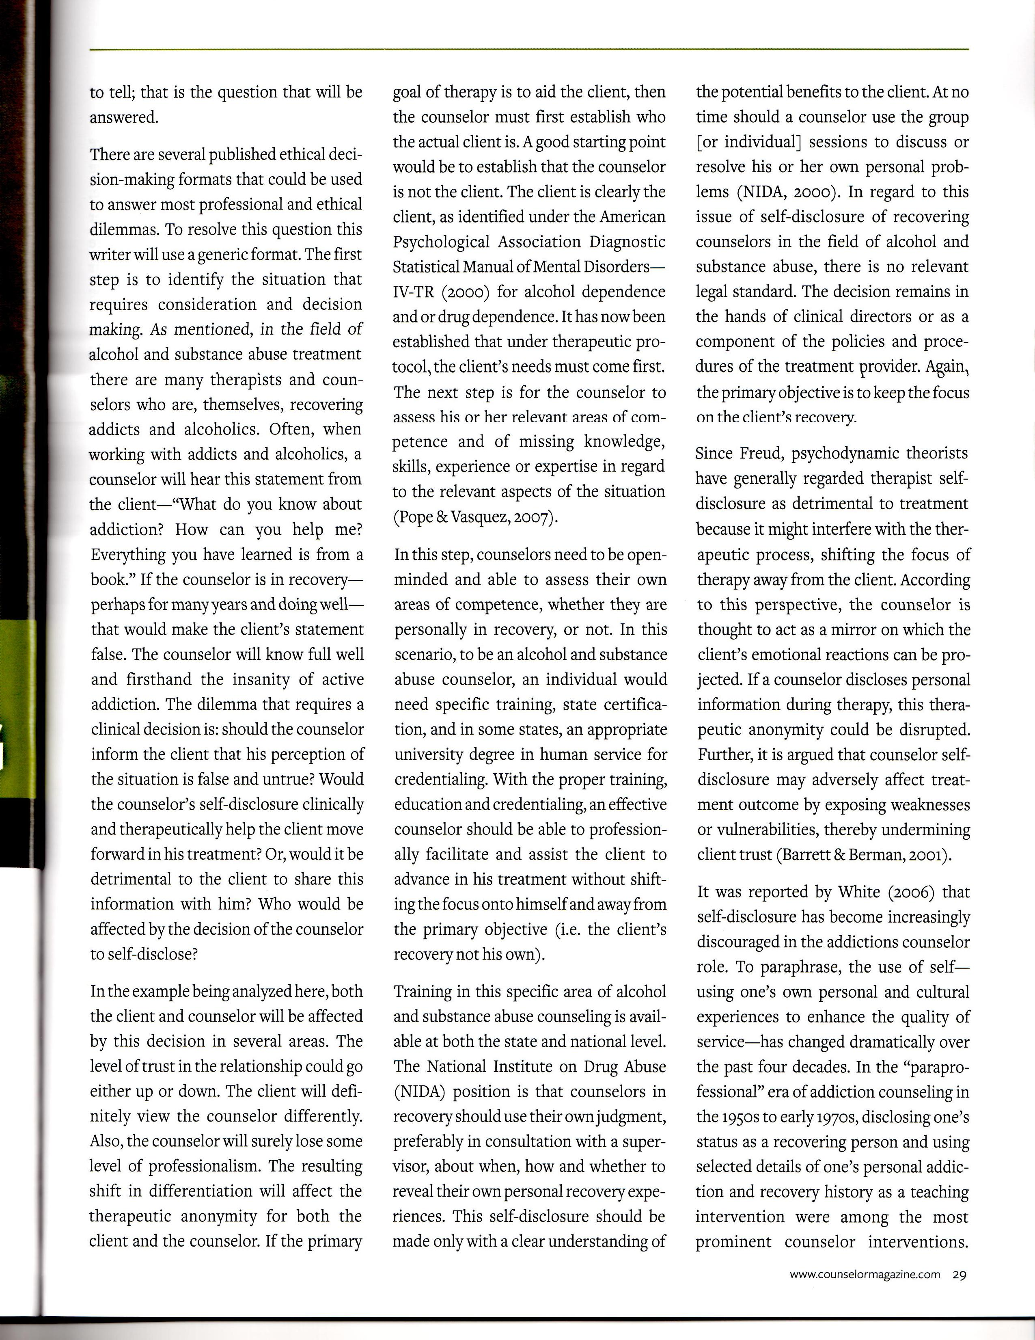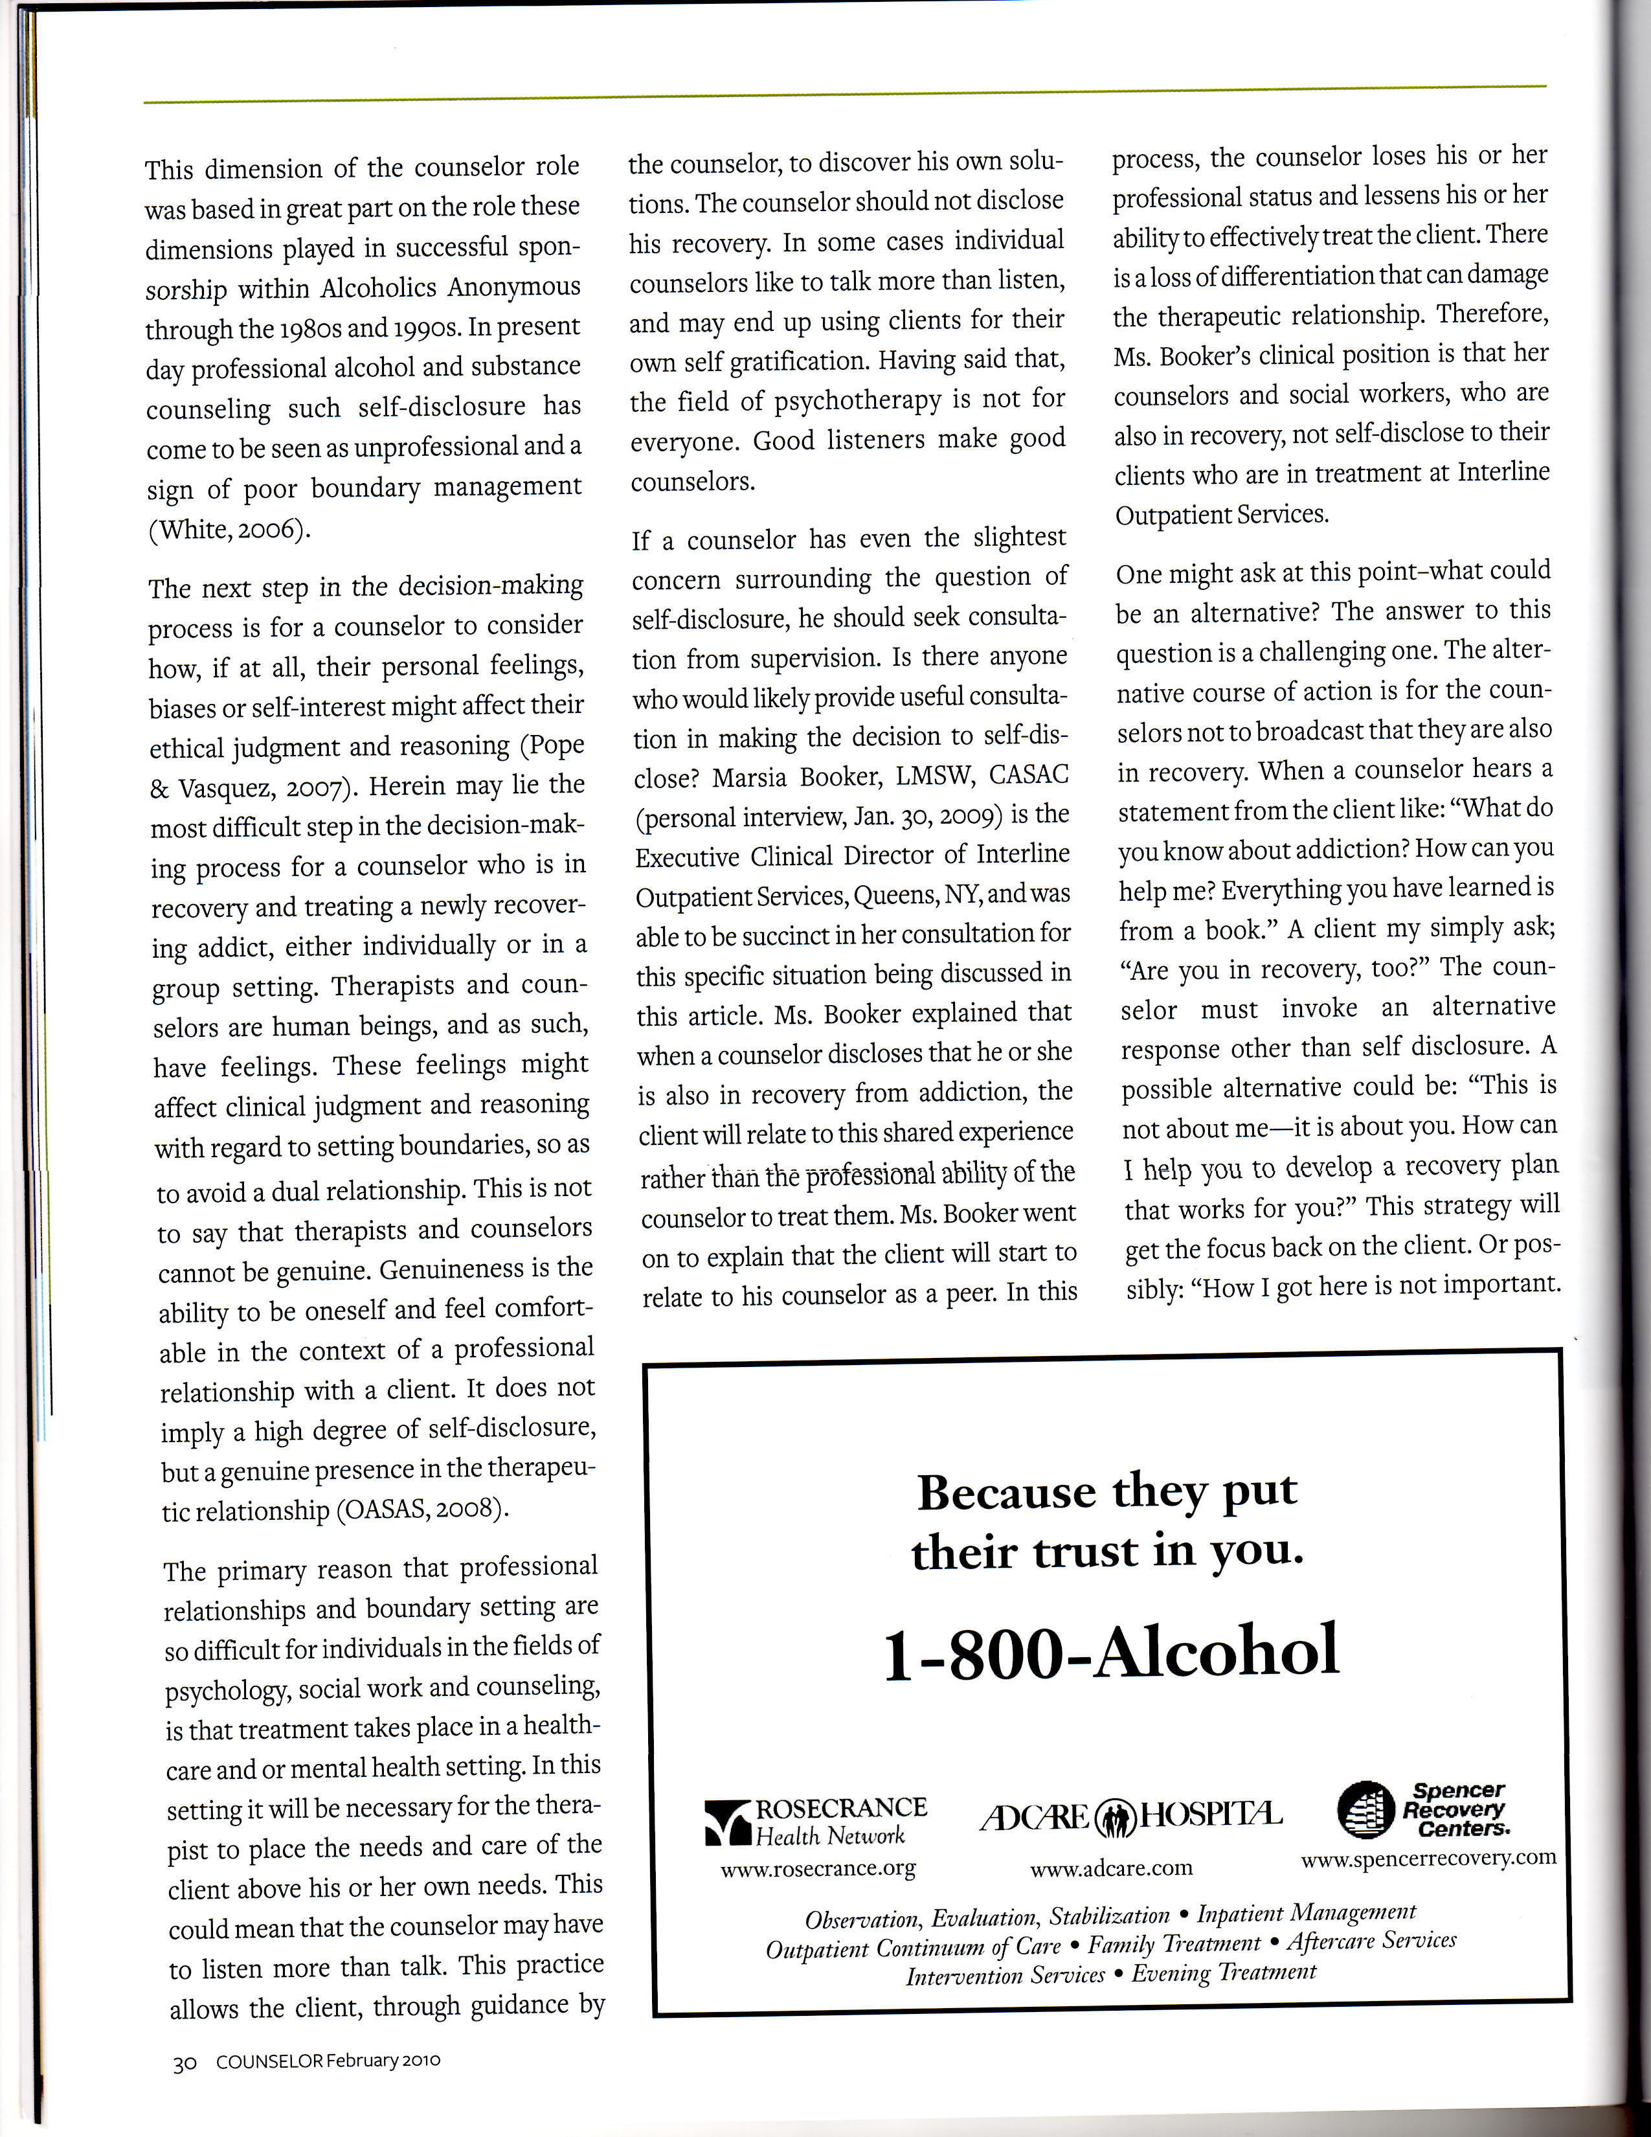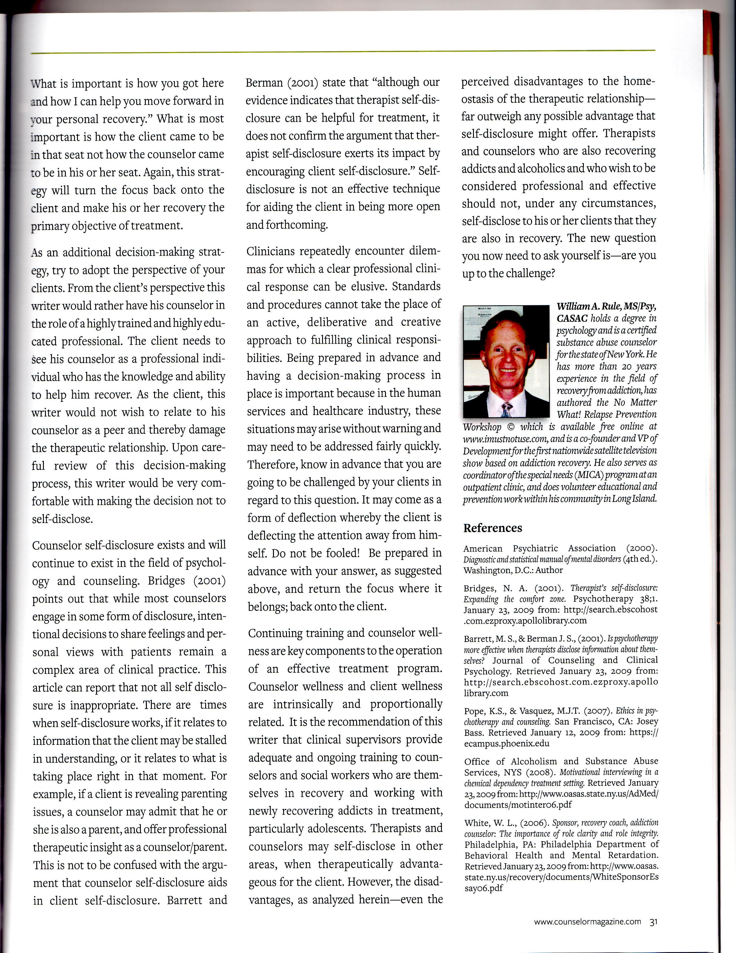

Self-Disclosure in Addiction Counseling: To Tell or Not to Tell?
by
William A. Rule, MS/Psy. CASAC

In the field of alcohol and substance abuse counseling there are many counselors and therapists who are, themselves, recovering addicts or alcoholics. There is a professional and ethical dilemma that occurs when the urge arises for the counselor to disclose that he can relate to his client’s struggle on a personal level, as he too is in recovery. Would doing so shift the focus on to the counselor and away from the client? This dilemma could place the counselor in conflict with personal and professional ethics not to self-disclose. What are the clinical and therapeutic advantages or disadvantages of self-disclosure in the field of alcohol and substance abuse counseling?
This article explains the importance of professional and ethical decision making with regard to counselor self-disclosure in the field of substance abuse counseling. There is a process whereby the counselor can make a responsible ethical decision based on criteria that will be the most advantageous to the client. Also, included in this article is an analysis of the implementation of a decision-making process on the specific dilemma, as defined above. Specifically, we will examine the clinical effects of self-disclosure as it relates to alcohol and substance abuse counselors, who are themselves in recovery, treating clients who are addicts and or alcoholics. Is self-disclosure in this scenario a professional and effective therapeutic technique? To tell or not to tell; that is the question that will be answered.
There are several published ethical decision-making formats that could be used to answer most professional and ethical dilemmas. To resolve this question this writer will use a generic format. The first step is to identify the situation that requires consideration and decision making. As mentioned, in the field of alcohol and substance abuse treatment there are many therapists and counselors who are, themselves, recovering addicts and alcoholics. Often, when working with addicts and alcoholics, a counselor will hear this statement from the client—“What do you know about addiction? How can you help me? Everything you have learned is from a book.” If the counselor is in recovery—perhaps for many years and doing well—that would make the client’s statement false. The counselor will know full well and firsthand the insanity of active addiction. The dilemma that requires a clinical decision is: should the counselor inform the client that his perception of the situation is false and untrue? Would the counselor’s self-disclosure clinically and therapeutically help the client move forward in his treatment? Or, would it be detrimental to the client to share this information with him? Who would be affected by the decision of the counselor to self-disclose?
In the example being analyzed here, both the client and counselor will be affected by this decision in several areas. The level of trust in the relationship could go either up or down. The client will definitely view the counselor differently. Also, the counselor will surely lose some level of professionalism. The resulting shift in differentiation will affect the therapeutic anonymity for both the client and the counselor. If the primary goal of therapy is to aid the client, then the counselor must first establish who the actual client is. A good starting point would be to establish that the counselor is not the client. The client is clearly the client, as identified under the American Psychological Association Diagnostic Statistical Manual of Mental Disorders—IV-TR (2000) for alcohol dependence and or drug dependence. It has now been established that under therapeutic protocol, the client’s needs must come first. The next step is for the counselor to assess his or her relevant areas of competence and of missing knowledge, skills, experience or expertise in regard to the relevant aspects of the situation (Pope & Vasquez, 2007).
In this step, counselors need to be open-minded and able to assess their own areas of competence, whether they are personally in recovery, or not. In this scenario, to be an alcohol and substance abuse counselor, an individual would need specific training, state certification, and in some states, an appropriate university degree in human service for credentialing. With the proper training, education and credentialing, an effective counselor should be able to professionally facilitate and assist the client to advance in his treatment without shifting the focus onto himself and away from the primary objective (i.e. the client’s recovery not his own).
Training in this specific area of alcohol and substance abuse counseling is available at both the state and national level. The National Institute on Drug Abuse (NIDA) position is that counselors in recovery should use their own judgment, preferably in consultation with a supervisor, about when, how and whether to reveal their own personal recovery experiences. This self-disclosure should be made only with a clear understanding of the potential benefits to the client. At no time should a counselor use the group [or individual] sessions to discuss or resolve his or her own personal problems (NIDA, 2000). In regard to this issue of self-disclosure of recovering counselors in the field of alcohol and substance abuse, there is no relevant legal standard. The decision remains in the hands of clinical directors or as a component of the policies and procedures of the treatment provider. Again, the primary objective is to keep the focus on the client’s recovery.
Since Freud, psychodynamic theorists have generally regarded therapist self-disclosure as detrimental to treatment because it might interfere with the therapeutic process, shifting the focus of therapy away from the client. According to this perspective, the counselor is thought to act as a mirror on which the client’s emotional reactions can be projected. If a counselor discloses personal information during therapy, this therapeutic anonymity could be disrupted. Further, it is argued that counselor self-disclosure may adversely affect treatment outcome by exposing weaknesses or vulnerabilities, thereby undermining client trust (Barrett & Berman, 2001).
It was reported by White (2006) that self-disclosure has become increasingly discouraged in the addictions counselor role. To paraphrase, the use of self—using one’s own personal and cultural experiences to enhance the quality of service—has changed dramatically over the past four decades. In the “paraprofessional” era of addiction counseling in the 1950s to early 1970s, disclosing one’s status as a recovering person and using selected details of one’s personal addiction and recovery history as a teaching intervention were among the most prominent counselor interventions. This dimension of the counselor role was based in great part on the role these dimensions played in successful sponsorship within Alcoholics Anonymous through the 1980s and 1990s. In present day professional alcohol and substance counseling such self-disclosure has come to be seen as unprofessional and a sign of poor boundary management (White, 2006).
The next step in the decision-making process is for a counselor to consider how, if at all, their personal feelings, biases or self-interest might affect their ethical judgment and reasoning (Pope & Vasquez, 2007). Herein may lie the most difficult step in the decision-making process for a counselor who is in recovery and treating a newly recovering addict, either individually or in a group setting. Therapists and counselors are human beings, and as such, have feelings. These feelings might affect clinical judgment and reasoning with regard to setting boundaries, so as to avoid a dual relationship. This is not to say that therapists and counselors cannot be genuine. Genuineness is the ability to be oneself and feel comfortable in the context of a professional relationship with a client. It does not imply a high degree of self-disclosure, but a genuine presence in the therapeutic relationship (OASAS, 2008).
The primary reason that professional relationships and boundary setting are so difficult for individuals in the fields of psychology, social work and counseling, is that treatment takes place in a healthcare and or mental health setting. In this setting it will be necessary for the therapist to place the needs and care of the client above his or her own needs. This could mean that the counselor may have to listen more than talk. This practice allows the client, through guidance by the counselor, to discover his own solutions. The counselor should not disclose his recovery. In some cases individual counselors like to talk more than listen, and may end up using clients for their own self gratification. Having said that, the field of psychotherapy is not for everyone. Good listeners make good counselors.
If a counselor has even the slightest concern surrounding the question of self-disclosure, he should seek consultation from supervision. Is there anyone who would likely provide useful consultation in making the decision to self-disclose? Marsia Booker, LMSW, CASAC (personal interview, Jan. 30, 2009) is the Executive Clinical Director of Interline Outpatient Services, Queens, NY, and was able to be succinct in her consultation for this specific situation being discussed in this article. Ms. Booker explained that when a counselor discloses that he or she is also in recovery from addiction, the client will relate to this shared experience rather than the professional ability of the counselor to treat them. Ms. Booker went on to explain that the client will start to relate to his counselor as a peer. In this process, the counselor loses his or her professional status and lessens his or her ability to effectively treat the client. There is a loss of differentiation that can damage the therapeutic relationship. Therefore, Ms. Booker’s clinical position is that her counselors and social workers, who are also in recovery, not self-disclose to their clients who are in treatment at Interline Outpatient Services.
One might ask at this point–what could be an alternative? The answer to this question is a challenging one. The alternative course of action is for the counselors not to broadcast that they are also in recovery. When a counselor hears a statement from the client like: “What do you know about addiction? How can you help me? Everything you have learned is from a book.” A client my simply ask; “Are you in recovery, too?” The counselor must invoke an alternative response other than self disclosure. A possible alternative could be: “This is not about me—it is about you. How can I help you to develop a recovery plan that works for you?” This strategy will get the focus back on the client. Or possibly: “How I got here is not important. What is important is how you got here and how I can help you move forward in your personal recovery.” What is most important is how the client came to be in that seat not how the counselor came to be in his or her seat. Again, this strategy will turn the focus back onto the client and make his or her recovery the primary objective of treatment.
As an additional decision-making strategy, try to adopt the perspective of your clients. From the client’s perspective this writer would rather have his counselor in the role of a highly trained and highly educated professional. The client needs to see his counselor as a professional individual who has the knowledge and ability to help him recover. As the client, this writer would not wish to relate to his counselor as a peer and thereby damage the therapeutic relationship. Upon careful review of this decision-making process, this writer would be very comfortable with making the decision not to self-disclose.
Counselor self-disclosure exists and will continue to exist in the field of psychology and counseling. Bridges (2001) points out that while most counselors engage in some form of disclosure, intentional decisions to share feelings and personal views with patients remain a complex area of clinical practice. This article can report that not all self disclosure is inappropriate. There are times when self-disclosure works, if it relates to information that the client may be stalled in understanding, or it relates to what is taking place right in that moment. For example, if a client is revealing parenting issues, a counselor may admit that he or she is also a parent, and offer professional therapeutic insight as a counselor/parent. This is not to be confused with the argument that counselor self-disclosure aids in client self-disclosure. Barrett and Berman (2001) state that “although our evidence indicates that therapist self-disclosure can be helpful for treatment, it does not confirm the argument that therapist self-disclosure exerts its impact by encouraging client self-disclosure.” Self- disclosure is not an effective technique for aiding the client in being more open and forthcoming.
Clinicians repeatedly encounter dilemmas for which a clear professional clinical response can be elusive. Standards and procedures cannot take the place of an active, deliberative and creative approach to fulfilling clinical responsibilities. Being prepared in advance and having a decision-making process in place is important because in the human services and healthcare industry, these situations may arise without warning and may need to be addressed fairly quickly. Therefore, know in advance that you are going to be challenged by your clients in regard to this question. It may come as a form of deflection whereby the client is deflecting the attention away from himself. Do not be fooled! Be prepared in advance with your answer, as suggested above, and return the focus where it belongs; back onto the client.
Continuing training and counselor wellness are key components to the operation of an effective treatment program. Counselor wellness and client wellness are intrinsically and proportionally related. It is the recommendation of this writer that clinical supervisors provide adequate and ongoing training to counselors and social workers who are themselves in recovery and working with newly recovering addicts in treatment, particularly adolescents. Therapists and counselors may self-disclose in other areas, when therapeutically advantageous for the client. However, the disadvantages, as analyzed herein—even the perceived disadvantages to the homeostasis of the therapeutic relationship—far outweigh any possible advantage that self-disclosure might offer. Therapists and counselors who are also recovering addicts and alcoholics and who wish to be considered professional and effective should not, under any circumstances, self-disclose to his or her clients that they are also in recovery. The new question you now need to ask yourself is—are you up to the challenge?
References
American Psychiatric Association (2000). Diagnostic and statistical manual of mental disorders (4th ed.). Washington, D.C.: Author
Bridges, N. A. (2001). Therapist’s self-disclosure: Expanding the comfort zone. Psychotherapy 38;1. January 23, 2009 from: http://search.ebscohost.com.ezproxy.apollolibrary.com
Barrett, M. S., & Berman J. S., (2001). Is psychotherapy more effective when therapists disclose information about themselves? Journal of Counseling and Clinical Psychology. Retrieved January 23, 2009 from: http://search.ebscohost.com.ezproxy.apollolibrary.com
Pope, K.S., & Vasquez, M.J.T. (2007). Ethics in psychotherapy and counseling. San Francisco, CA: Josey Bass. Retrieved January 12, 2009 from: https://ecampus.phoenix.edu
Office of Alcoholism and Substance Abuse Services, NYS (2008). Motivational interviewing in a chemical dependency treatment setting. Retrieved January 23, 2009 from: http://www.oasas.state.ny.us/AdMed/documents/motinter06.pdf
White, W. L., (2006). Sponsor, recovery coach, addiction counselor: The importance of role clarity and role integrity. Philadelphia, PA: Philadelphia Department of Behavioral Health and Mental Retardation. Retrieved January 23, 2009 from: http://www.oasas.state.ny.us/recovery/documents/WhiteSponsorEssay06.pdf
William A. Rule, MS/Psy, CASAC holds a BA (Summa) and Master of Science degree in psychology and is a NYS certified alcohol and substance abuse counselor (CASAC) with over 20 years experience in the field of recovery from addiction. Mr. Rule has authored the No Matter What! Relapse Prevention Workshop © which is available free online with other training and information at www.imustnotuse.com. Formally the co-founder and VP of Development for the first nationwide satellite television show based on recovery. He is the founder and Executive Director of the Institute of Learning and Development providing quality continuing education for counselors and interns. Mr. Rule is currently a primary counselor and Director of Provider Relations for an outpatient program and he does volunteer educational and prevention work within his community in Long Island.
© William A. Rule 2010

